Protection of Personal Data - Application Form

**İSTANBUL DENİZ OTOBÜSLERİ SAN. ve TİC. A.Ş. DATA OWNER APPLICATION FORM**

Some rights to make demands were bestowed to personal data owners who are defined as related person (hereinafter shall be referred to as "Application Owner") at 6698 numbered Law of Protecting Personal Data ("PPD Law"), in related with processing of personal data in 11th article of Law.

In accordant with PPD Law's 13th Article's first paragraph; applications which will be made to our company who is responsible from data in related with these rights shall be made as written or by other methods which are designated by Board of Protecting Personal Data ("Board"). In this context the applications that are made to our Company as "written", shall be delivered to us via hand by using hereby form, over notary or by registered electronic mail.

In accordant with Law's 13th Article's 2nd paragraph your applications delivered to us shall be replied "as promply as proctible and in thirty days at the latest" starting from date of your application was reached us according the quality of demand. Our replies shall be delivered to you as written or from electronic environment as per provision of Law's 13th article.

Information and documents that were requested from you shall be provided complete and correct according to qualification of your form and demand. In case information was not provided as it should be, there could be problems regarding handling researches which shall be done by our Company in line with your demand in a complete and qualified way. In this case our Company's legal rights are reserved. For this reason, related form shall be sent as it contains requested information and documents in accordant with quality of your request/demand.

**1. Applicant Contact Information:**

Please fill the areas below in order for us to contact with you and validate your identity.

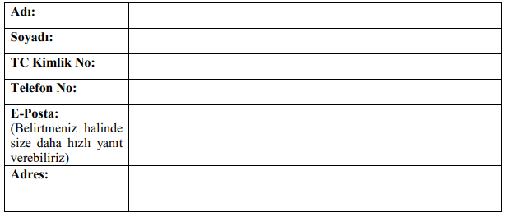

In addition your provided information above are requested with purpose of taking more detailed information about your application, to inform you about our inspection processes and delivering results of your application.

**2. Please select your relationship with our company.**

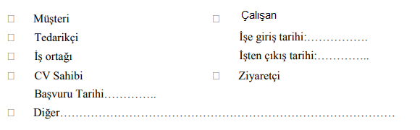

**3. Please select your application's preferred reply method.**

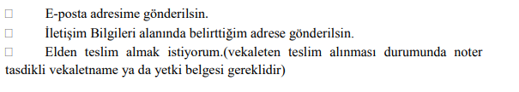**4. Please state your application reason in scope of Protection of Personal Data Law:**

Please state what are the personal data that are subject to your request. We kindly request you to write your demand/request in detail regarding your personal data.



In line with requests that I stated above, I hereby request that information shall be provided to me as my application to be evaluated in accordant with Law's 13th article.

I hereby state and undertake that my information and documents that I provided to you at this application are correct and up to date, I was informed that your Company may request additional information in order to finalize my application and if additional cost is required I might pay a price that shall be designated by Board.

Applicant (Personal Data Owner)

Name Surname:

Application Date:

Signature:

[Click](https://www.migroskurumsal.com/userfiles/image/pdf/migros-kvk-basvuru-formu-v2-09042018.pdf" \t "_blank) to download the application form.